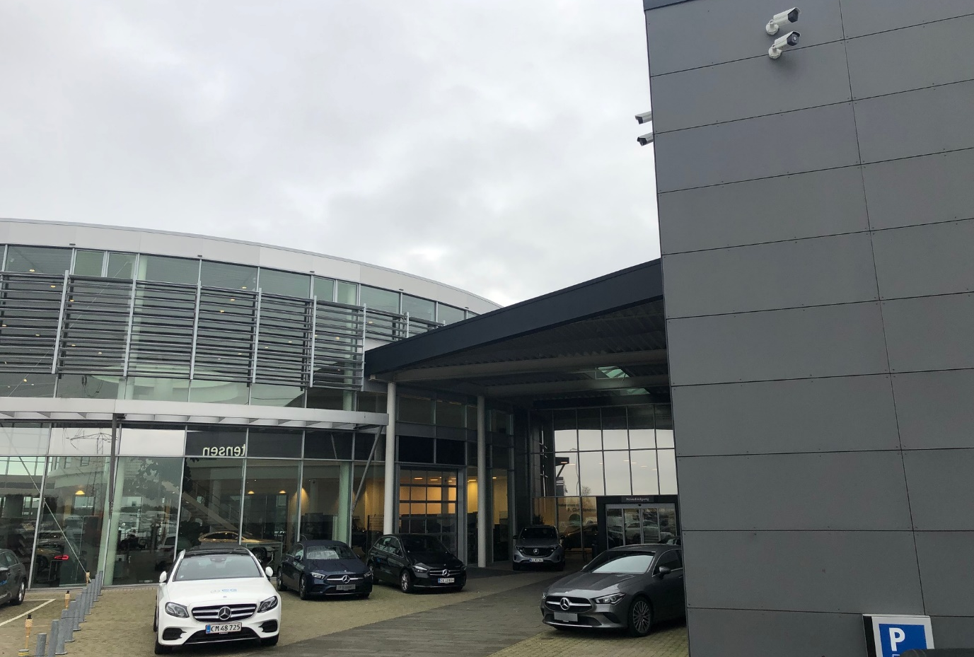
Upgraded perimeter detection for car dealership
Car theft is a concern for many people, so imagine if you were responsible for a whole load of them. Car dealer P. Christensen in Denmark knows this headache from personal experience, suffering a number of thefts from their fenced area. It was time to ramp up security, so they turned to Telesikring, the largest private-owned security company in Denmark, for a perimeter detection solution. Telesikring upgraded security with a solution using Hikvision surveillance cameras.
Challenge
Despite existing security measures like electric fences and burglar alarms, the car dealership was still experiencing thefts. Thieves were managing to come up with increasingly imaginative ways to beat the system – like crawling over fences and even digging underneath them.
They stole all sorts of items, including wheels and catalysts from the cars and vans exhibited at the site. These represent quite some value, and the cost of these losses was mounting up.
They needed a solution which could work for them in all sorts of weather conditions and in the dead of night – the most vulnerable time. The premises have some quite remote outlying areas, which were also particularly at risk.
Solution
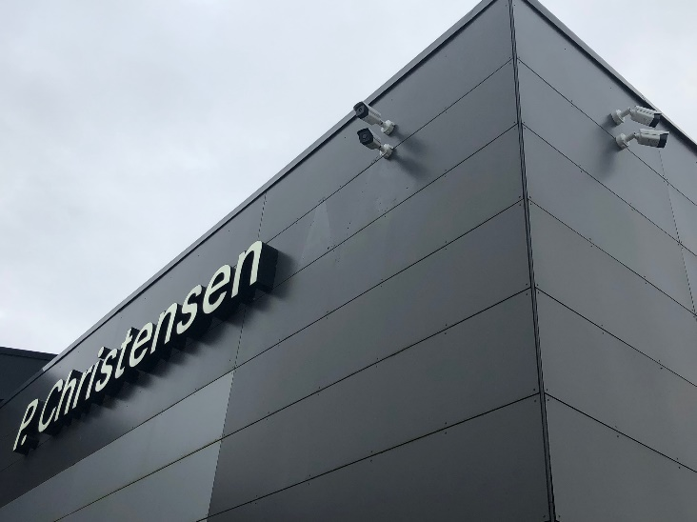
The car dealership is now monitored using a perimeter detection solution made up of both conventional and thermal cameras. These cameras are connected to a Milestone VMS with analysis software. In turn, this has a direct connection to the Jutland Control Center, a local Alarm Receiving Center that monitors the property 24/7. Now it’s not possible to enter the property outside of opening hours - day or night, without this being registered by the control center. The information they receive from the analysis software enables them to make an informed decision on their response, for example sending a guard patrol.
Thermal cameras were chosen because of the reliability in all weather conditions. This solution specifically used the Thermal Network Bullet Camera (DS-2TD2136-10). Once the thermal camera detects a break-in, it sends an alarm to the ARC and the operator there can use the low-light clarity delivered by the DarkFighter cameras (DS-2CD4B26FWD-IZS) also present to verify the alarm. These camera provide excellent images even in the lowest of light levels, making the ideal for remote verification.
Henrik Finn Sanderlund, Quality Manager at P. Christensen, says: “Yes, we are very satisfied! Since the deployment of the system, this has effectively prevented burglary and theft. The solution was deployed on a Thursday and on Friday the solution caught the first break in, effectively preventing it.”
Managers at P. Christensen can now rest at night, safe in the knowledge that security innovation is keeping an eye on the property.

Click here to find out more about Hikvision Thermal cameras.

Click here to find out more about DarkFighter technology

